
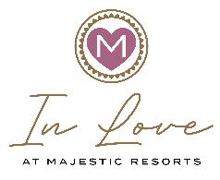

Majestic Resorts Wedding Contract

WEDDING COUPLE´S INFORMATION**

Partner A: (BRIDE / GROOM) Pronoun: (HE / SHE / THEY)
Full Name: __________________________________________________________________________
Phone Number: __________________________ Email: ______________________________________
Address: ____________________________________________________________________________
City of Residence/State: ____________________ Country: ___________________ Zip Code: ________

Partner B: (BRIDE / GROOM) Pronoun: (HE / SHE / THEY)
Full Name: __________________________________________________________________________
Phone Number: __________________________ Email: ______________________________________
Address: ____________________________________________________________________________
City of Residence/State: ____________________ Country: ___________________ Zip Code: _______

TRAVEL AGENT´S INFORMATION
Name: ___________________________________ Agency: ___________________________________
Phone Number: __________________________ Email: ______________________________________

HOTEL BOOKING INFORMATION (if already confirmed)
Hotel: _______________________________________________________________________________
Room Type: _____________________________________________ Section: Family / Club (Adults Only)
Check-In: _____/_____/_____ Check-Out: _____/_____/_____ Confirmation Number: ______________
Arrival Flight & Time: ___________________________________________________________________
Departure Flight & Time: ________________________________________________________________

**Mandatory Information

Please return this document in an editable format.

